# **Computer Parts**

**A computer is an electronic machine that processes data. Information given to the computer is called data. Computer works very fast. It saves your time and energy. It does not make mistakes. It can remember a lot of things. The basic parts of a computer are shown in the picture given here.**

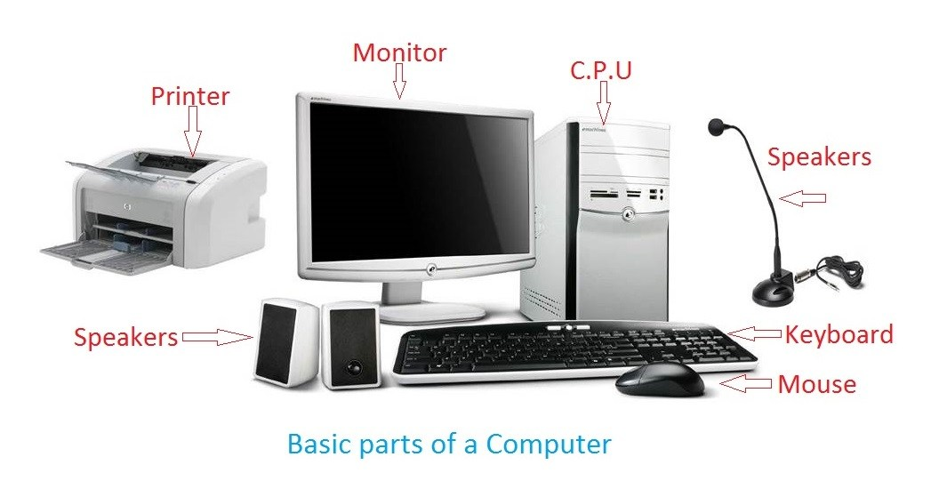

#### Input Devices:

Devices that help us put data into the computer are called input devices. They help in giving instructions to the computer. **Let us learn about a few input devices**.

**Keyboard:**

##### [keyboard information for Kides](https://www.informationq.com/about-the-basic-parts-of-a-computer-with-devices/keyboard-information-for-kides/)

The keyboard is used for entering data into the computer system. It can type words, numbers and symbols.

**Mouse:**

##### [mose information for kide](https://www.informationq.com/about-the-basic-parts-of-a-computer-with-devices/mose-info-for-kide/)

The mouse is a pointing device. You can give input to the computer with the help of the mouse.

#### **Processing Device:**

All the inputs are stored, sorted, arranged and changed by a computer. The device that helps a computer do so is called the processing device. The processing device in a computer is known as**Central Processing Unit (CPU)**

**[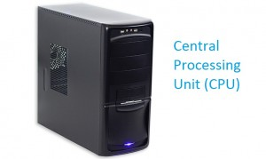](https://www.informationq.com/about-the-basic-parts-of-a-computer-with-devices/cpu-information-for-kides/)**

#### **Output Devices:**

The parts of a computer that help us to show the results of processing are called out devices. **Let us learn about a few output devices.**

**Monitor**:

##### [Computer monitor information for Kides](https://www.informationq.com/about-the-basic-parts-of-a-computer-with-devices/computer-monitor-information-for-kides/)

A **monitor** looks like a TV screen. It shows whatever you type on the keyboard or draw with the mouse.

#### **Storage Devices:**

The parts of a computer which are used for storing data are called. Storing data are called storage devices. They help in storing any work done on a computer permanently. **Let us learn about a few storage devices.**

**Hard Disk:**

##### *[Computer hard disk information fo Kides](https://www.informationq.com/about-the-basic-parts-of-a-computer-with-devices/computer-hard-disk-information-fo-kides/)*

Inside the CPU there is a hard disk. It is made up of one or more metallic disks. It stores a large amount of information.

**Compact Disc (CD):**

##### [Compact Disc (CD) information for Kides](https://www.informationq.com/about-the-basic-parts-of-a-computer-with-devices/compact-disc-cd-information-for-kides/)

A CD stores many times more information than a floppy disk. It works when it is inserted into the CD drive. The CD drive is fixed in the CPU**. Note:**Not handling the CD properly may result in loss of data stored.